# Bench introduction

## Dataset overview

The challenge datasets were provided by FEMTO-ST Institute. All data can be used for bearing remaining useful life prediction.

## Bench information

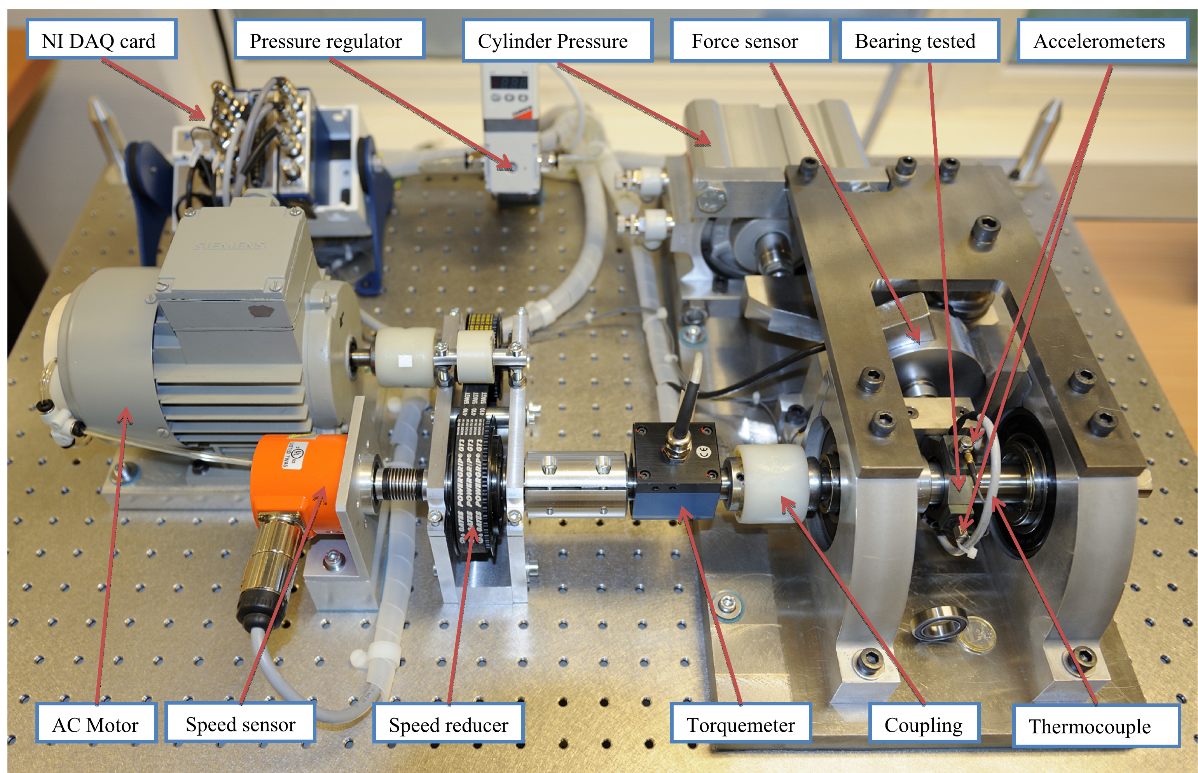

**Figure 1. Overview of PRONOSTIA[1]**

Experiments were carried out on a laboratory experimental platform (PRONOSTIA) that enables accelerated degradation of bearings under constant and/or variable operating conditions, while gathering online health monitoring data (rotating speed, load force, temperature, vibration). [1]

## Characteristics of tested bearings

* Fitted with two synthetic rubb er seals to prevent leakage of lubricant as well as entry of dust, water and other harmful material
* Outside Race Diameter D=32 mm
* Inside Diameter d=20 mm
* Thickness B=7 mm
* Load Ratings Static: 2470 N
* Load Ratings Dynamic: 4000 N
* Maximum Speed : 13000 rpm [1]

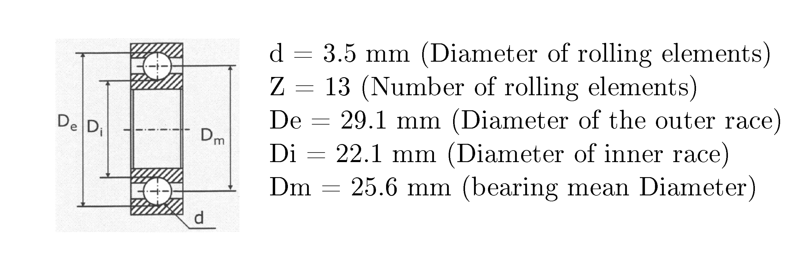

## Vibration signals

* Vibration signals (horizontal and vertical)
* Sampling frequency: 25.6 kHz
* Recordings: 2560 samples (i.e. 1/10 s) are recorded each 10 seconds [1]

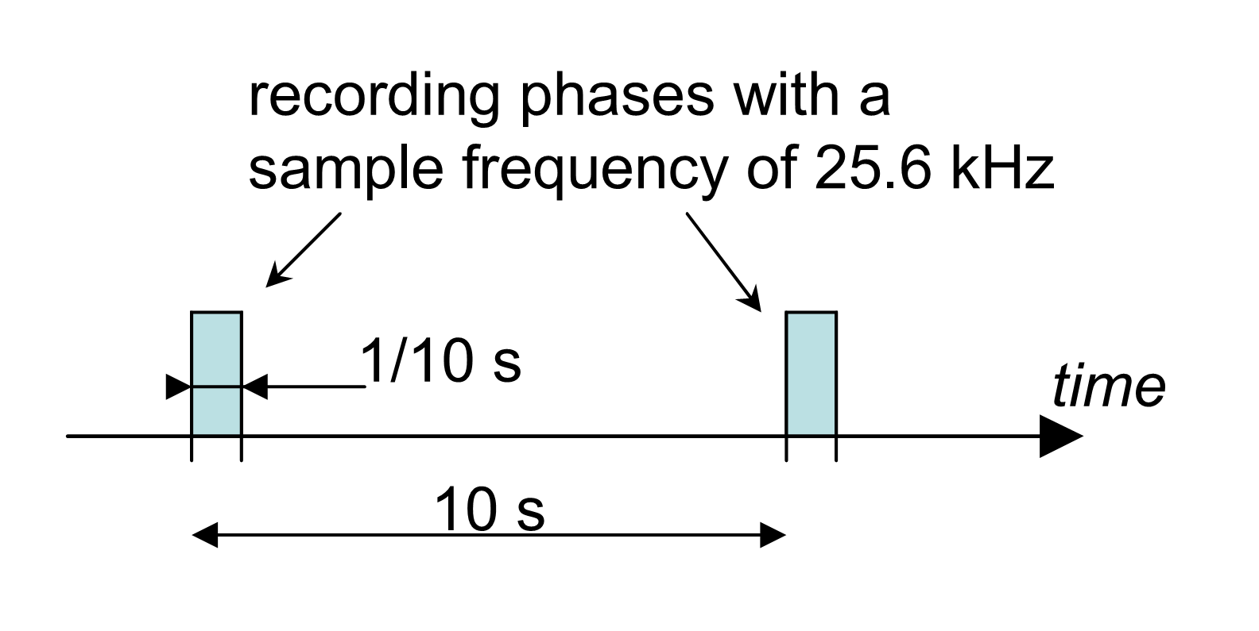

**Figure 2. Illustration of acquisition parameters for vibration signals[1]**

## Temperature signal:

* Temp erature signals
* Sampling frequency: 10 Hz
* Recordings: 600 samples are recorded each minute

### Characteristics of the temperature sensor

Temperature sensor Type platinum RTD PT100 PROSENSOR

* Class 1/3 DIN norm IEC 751
* Nominal resistance : 100 ohms
* Usage range : -200 to +600 °C
* Diameter : 2.8 mm
* Length : 25 mm

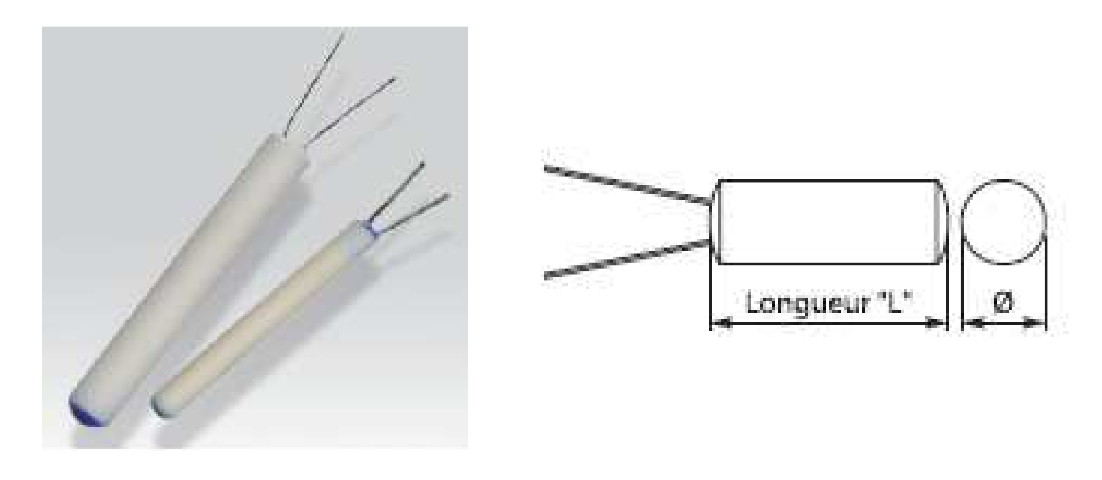

## Operating conditions

* Conditions 1: First op erating condi tions: 1800 rpm and 4000 N;
* Conditions 2: Second op erating condi tions: 1650 rpm and 4200 N;
* Conditions 3: Third op erating cond itions: 1500 rpm and 5000 N

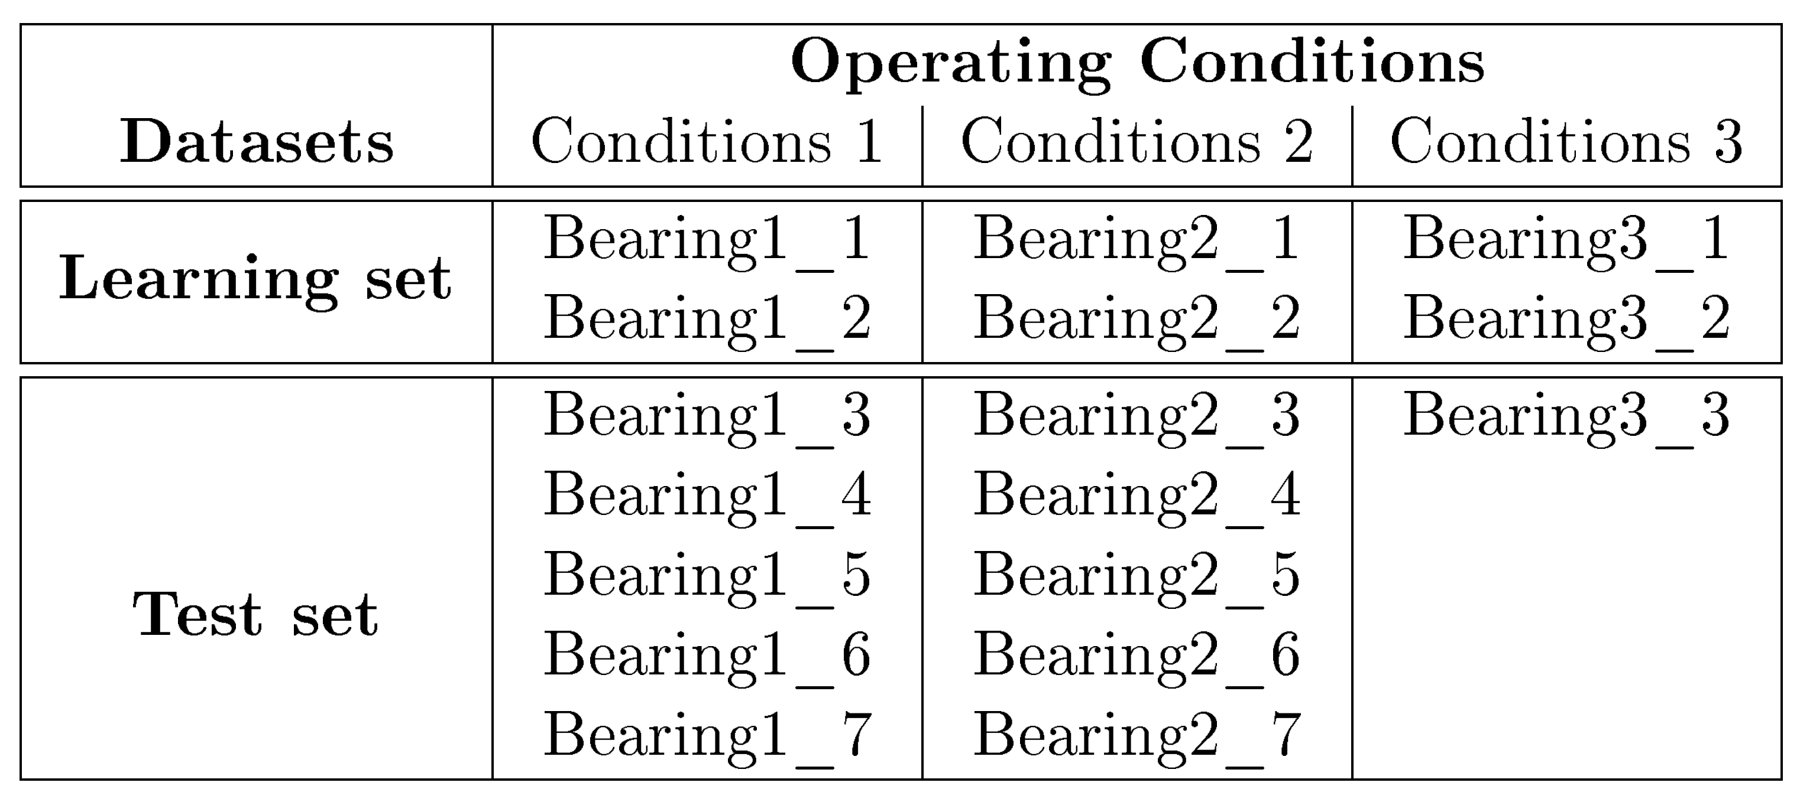

**Table 1: Datasets of IEEE 2012 PHM Prognostic Challenge[1]**

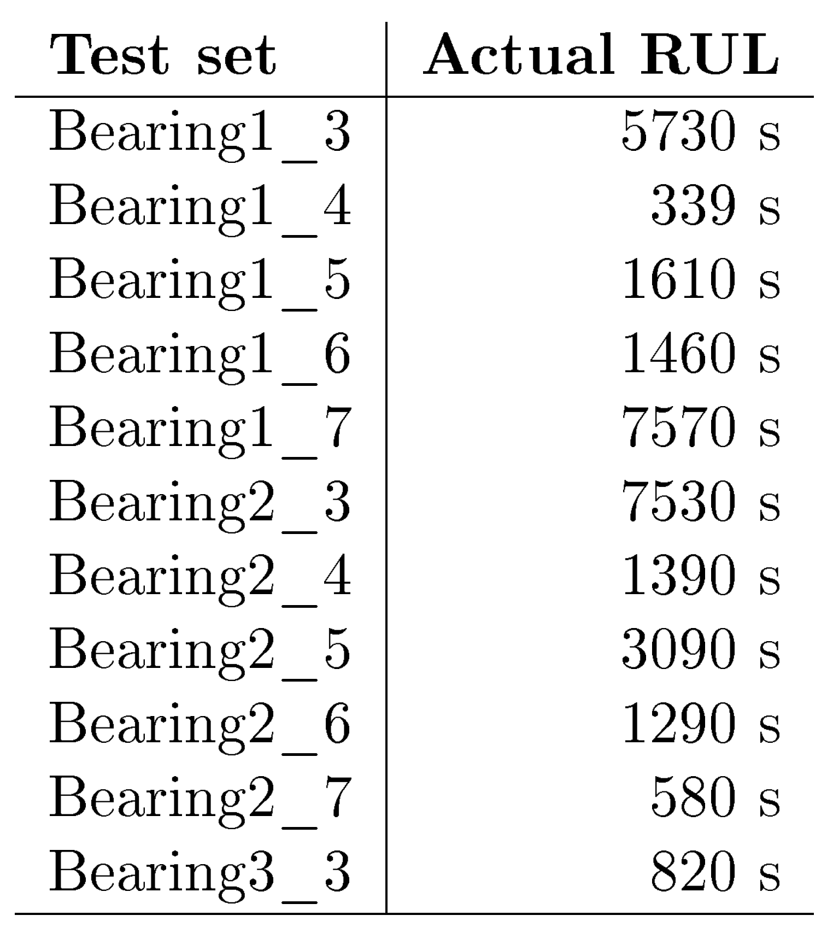

**Table 2: Actual RULs to be estimated[1]**

# Reference

[1] Lessmeier C, Kimotho J K, Zimmer D, et al. Condition monitoring of bearing damage in electromechanical drive systems by using motor current signals of electric motors: A benchmark data set for data-driven classification[C]//PHM Society European Conference. 2016, 3(1).